Kem Chan
CS 360
Mar 11, 2026
Assignment 2-2: User Components and Data

The mobile app that I have decided to explore is the YouTube app and diving in provides a few different screens that allow the user to explore content that was sourced from other users before being uploaded. Upon first opening mobile apps user that is brought to a home screen which displays videos that a user may be interested in that came with buttons that could mute the video and display closed captions. The other feature that comes up is being able to tap the video that could enlarge the content and allow other users to explore similar content and comments that were left by other users on the video. Additionally, along with the top of the app there are buttons such as notifications buttons that would allow users to explore new videos other users uploaded that you had subscribed to. Another button is a magnifying glass button that allows a user to enter queries into a search field and a profile icon button that would allow users to edit their personal details that was entered in the application.
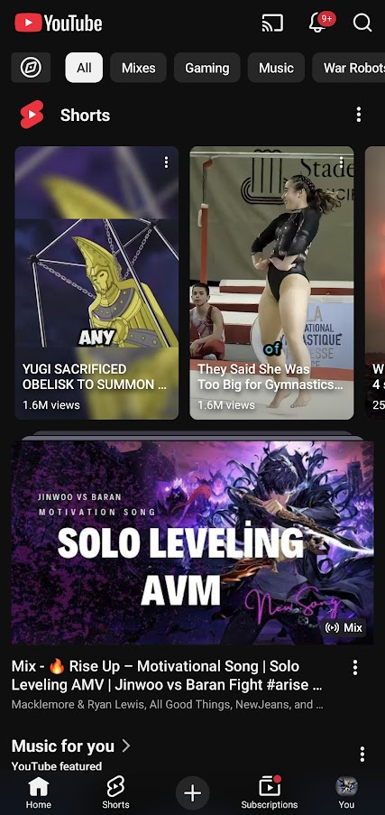 screen shot from mobile app.
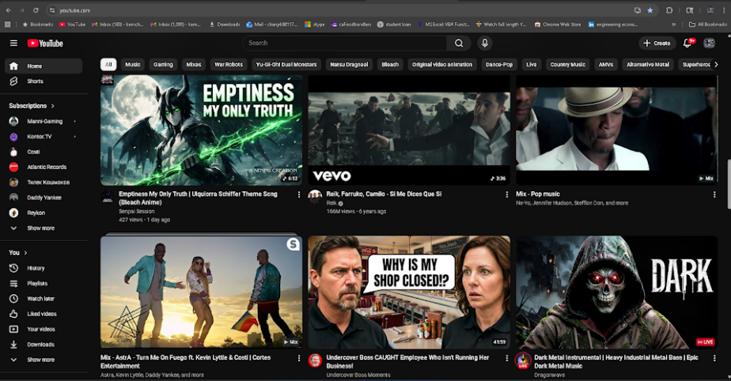 screenshot from computer.

The data on YouTube mobile app is all sourced from users uploading to content. Users can create content and then be able to share it online by uploading it to YouTube either on a computer or on a mobile device. The exception to the data is that it is sourced from the end users is when YouTube shares are commercially available and is used to produce movies or television shows in their separate YouTube Tv app. This content is usually created from media studios that YouTube allow users to purchase or rent to view.
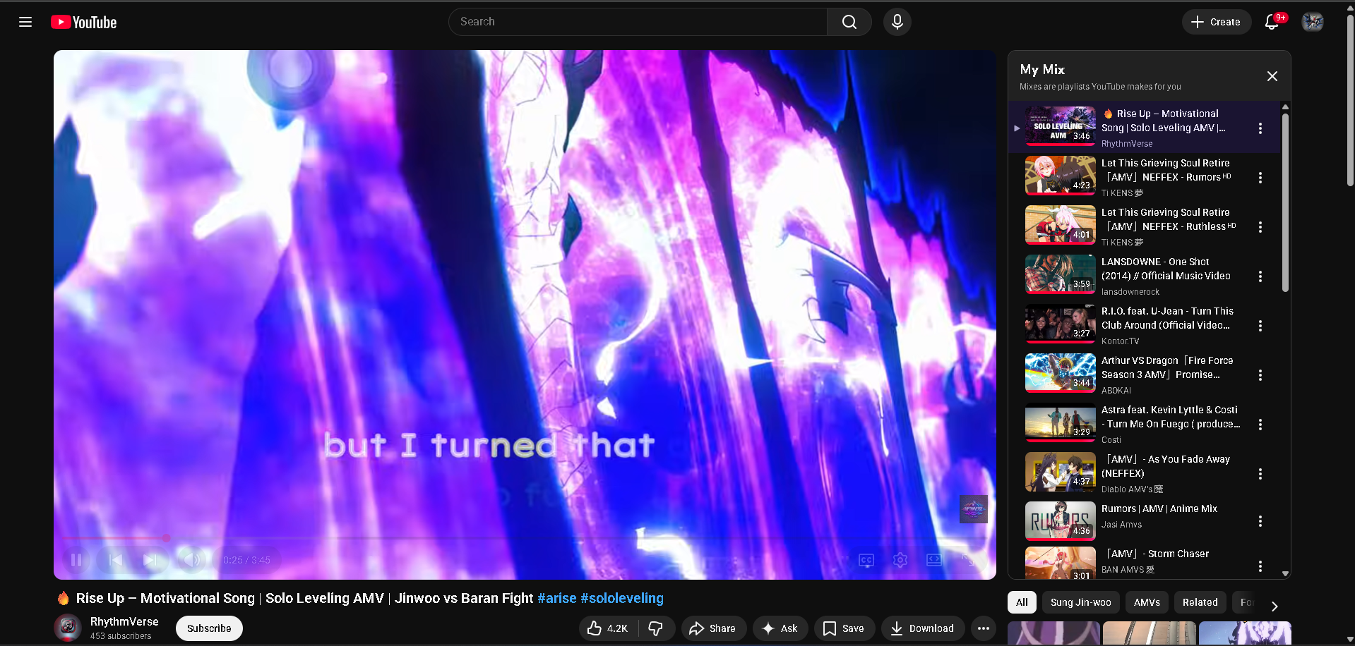
The YouTube mobile application is used primarily to entertain, and users have a variety of ways to interact with not just the data uploaded on the application, but additionally other users needed to fulfill any needs. Users can start with buttons that have both like, dislike, share, ask, save, download, and more options with the public and available to other users which would help content creators know what content users like and dislike out of the material that was uploaded. The ask button where it can tap into AI usage to be able to ask questions regarding the video while checking the comments on the video. The next Download button allows the users to save the video that can be accessed later. The YouTube mobile application allows the user to comment on videos to share thoughts and interact with other users to entertain themselves with opinions. There is also a videos list that shows relative material similar to what was searched mixed with previous searches that is catered to the user.
